***Netflix Movies & TV Series Analysis***

**Abstract :**

This project aims to analyse Netflix’s vast library of movies and TV series using interactive data visualization in Power BI. The dashboard provides insights into the distribution of content across genres, ratings, countries, and formats. By combining descriptive analytics and visualization, the project helps identify trends in audience preferences, regional contributions, and quality ratings. The findings assist in understanding Netflix’s content strategy and viewer engagement.

**Introduction:**

Netflix is one of the largest streaming platforms in the world, offering thousands of movies and TV series across multiple genres and countries. With its rapidly expanding content base, analysing the available titles can provide useful insights for both business and viewers.

The main objectives of this project are:

* To explore the number of titles by format (movies vs. TV series).
* To analyse ratings and viewer engagement across different genres.
* To examine the geographical distribution of Netflix titles.
* To identify patterns in user preferences and quality indicators

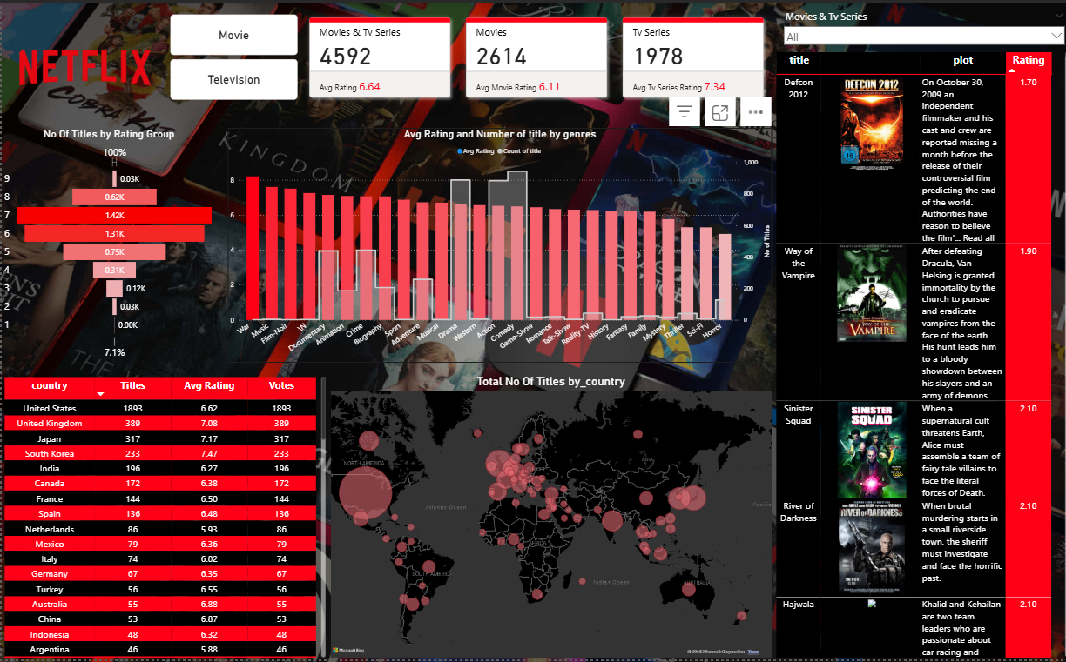**NETFLIX Movies and Tv Series Analysis Dashboard**

**Dashboard Explanation:**

**New Card :**

* **Total Titles:** 4,592
* **Movies:** 2,614 (Avg Rating: 6.11)
* **TV Series:** 1,978 (Avg Rating: 7.34)
* **Overall Avg Rating:** 6.64

📌 Insight: TV series generally have higher ratings compared to movies, suggesting better audience reception.

**Funnel Chart :**

* Titles are grouped by rating ranges.
* The majority of titles fall within the **6–7 rating range**, followed by the 5–6 range.

📌 Insight: Most Netflix content is moderately rated, with fewer extremely high or low-rated titles.

**Bar and Line Chart :**

* X-axis: Genres (Drama, Comedy, Action, Thriller, etc.)
* Bars: Number of titles
* Line: Average rating per genre

📌 Insight:

* Genres like **Documentary, Animation, and Biography** show higher ratings.
* Genres like **Horror and Sci-Fi** have comparatively lower ratings.
* **Drama and Comedy** dominate in terms of number of titles.

**Table :**

* **Top countries by number of titles:**
  + United States (1893 titles, avg rating 6.62)
  + United Kingdom (389 titles, avg rating 7.08)
  + Japan (317 titles, avg rating 7.17)
  + South Korea (233 titles, avg rating 7.47)
* Map visualization highlights concentration of Netflix content around **North America, Europe, and Asia**.

📌 Insight: The United States dominates in content production, while Asian countries like **Japan and South Korea** maintain higher average ratings.

**Table :**

* This section displays:
  + **Poster** of the selected movie/series.
  + **Plot** (short description of the storyline).
  + **Rating** (numerical rating for that title).
* A **search bar (slicer)** is included, allowing users to quickly search for a specific movie or TV show.
* Titles can be explored individually, making this panel act like a **mini information system inside the dashboard**.

📌 Insight: This feature provides an interactive way to explore the dataset title by title, making the dashboard more user-friendly and practical for detailed exploration rather than only high-level analysis.

**Findings :**

• Netflix hosts more **movies** than TV series, but TV series enjoy higher ratings.

• **Drama and Comedy** are the most common genres, while **Documentaries and Animation** achieve higher ratings.

• The **United States** contributes the most titles, but **Asian countries (Japan, South Korea)** contribute higher-rated content.

• There is a significant proportion of **average-rated content (6–7 range)**, with limited highly rated shows.

• Some extremely low-rated titles exist, showing variation in quality control.

**Conclusion :**

The Netflix dashboard highlights key trends in content distribution and ratings. Movies dominate in quantity, but TV series achieve higher ratings. The U.S. contributes the most titles, while countries like Japan and South Korea produce higher-quality content. Drama and Comedy are the most common genres, but Documentaries and Animation receive the best ratings. Overall, the dashboard provides valuable insights into Netflix’s global content strategy and audience preferences.

Submitted By

**Selvakumar M**